Salon Management System
TECHNICAL REPORT



SUBMITTED BY
Urwa
2024-ag-4306
ADVISED BY
Dr Qamar Nawaz
A TECHNICAL REPORT SUBMITTED IN PARTIAL FULFILLMENT OF REQUIREMENT FOR THE DEGREE OF
BACHELOR OF SCIENCE
IN
Computer Science
DEPARTMENT OF COMPUTER SCIENCE
FACULTY OF SCIENCES
UNIVERSITY OF AGRICULTURE FAISALABAD
DECLARATION

I hereby declare that the contents of the report “Salon Management System” is project of my own and no part has been copied from any published source (except the references). I further declare that this work has not been submitted for award of any other diploma/degree. The university may take action if the information provided is found false at any stage. In case of any default the scholar will be proceeded against as per UAF policy.

_________________
Urwa
2024-ag-4306
CERTIFICATE

To,
The Controller of Examinations,
University of Agriculture,
Faisalabad.

The supervisory committee certify that Urwa bearing AG # 2024-ag-4306 has successfully completed his project in partial fulfillment of requirement for the degree of B.Sc. Computer Science under our guidance and supervision.

_____________________________________
Dr. Qamar Nawaz
Department of Computer Science

_______________________________________
Dr. Muhammad Ahsan Latif
Chairman,
Department of Computer Science

ACKNOWLEDGEMENT

I thank all who in one way or another contributed to the completion of this report. I am so grateful to the Department of Computer Science for making it possible for me to study here. My special and heartily thanks to my advisor, Supervisor Dr Qamar Nawaz who encouraged and directed me. His/her challenges brought this work towards a completion. It is with his/her supervision that this work came into existence. For any faults, I take full responsibility. I am thankful to my fellow students whose challenges and productive critics have provided new ideas for the work. Furthermore, I also thank my family who encouraged me and prayed for me throughout the time of my research. May the Almighty God richly bless all of you

ABSTRACT

The Salon Management System is a desktop-based application developed to automate and streamline daily salon operations, replacing inefficient manual methods such as paper registers and handwritten records. Many salons face recurring problems including scheduling conflicts, data loss, billing errors, and delayed services — all of which reduce productivity and negatively affect customer satisfaction. This project addresses these challenges by providing a centralized, computerized solution built using the .NET Framework (C#) with Windows Forms for the graphical user interface and MySQL as the backend database.
The system comprises five core modules: User Login and Authentication, Customer Management, Service Management, Appointment Booking, and Billing and Payment. Each module was developed following the Agile process model, allowing incremental development, continuous testing, and module-wise delivery. System design was supported by UML diagrams including Use Case, Sequence, and Class Diagrams, alongside Data Flow Diagrams (Context, Level 0, and Level 1), an ER Diagram, a Database Model, and a 3-Tier Architecture diagram.
The system was evaluated through structured test cases covering all five functional modules. A 100% pass rate was achieved across all test scenarios, confirming that the system performs reliably under standard operating conditions. The interface was designed with a user-first philosophy, ensuring salon staff with basic computer skills can operate the system with minimal training. The Salon Management System successfully meets its objectives by reducing manual workload, improving data accuracy, and providing an efficient and user-friendly solution for modern salon management.

Table of Contents
Chapter 1 – INTRODUCTION 8
1.1 Background 8
1.2 Description 8
1.3 Problem Statement 8
1.4 Scope 8
1.5 Objectives 9
1.6 Feasibility 9
1.6.1 Technical Feasibility 9
1.6.2 Schedule Feasibility 9
1.6.3 Economic Feasibility 9
1.6.4 Cultural Feasibility 9
1.6.5 Legal/Ethical Feasibility 10
1.6.6 Resource Feasibility 10
1.6.7 Operational Feasibility 10
1.7 Requirements 10
1.7.1 Functional Requirements 10
1.7.2 Non-Functional Requirements 11
1.7.3 Hardware Requirements 11
1.7.4 Software Requirements 11
1.8 Stakeholders 11
Chapter 2 – MATERIALS & METHODS 12
2.1 Process Model 12
2.2 Tools & Technologies 12
2.3 Design 12
2.3.1 Use Case Diagrams 13
2.3.2 Usage Scenario 13
2.3.3 Sequence Diagram 17
2.3.4 Class Diagram 18
2.3.5 Data Flow Diagram 19
2.3.6 ER Diagram 23
2.3.7 Database Model 23
2.3.8 Architecture 24
Chapter 3 – RESULTS & DISCUSSION 26
3.1 Testing Methodology 26
3.2 Test Case Design Principles 26
3.3 Conclusion 28
Chapter 4 – USER MANUAL 29
Chapter 5 –TECHNICAL MANUAL 31

List of Figures

Figure ‎1.1 Stakeholders 8
Figure ‎2.1 Agile Activities 9
Figure 2.‎2 Use Case Diagram 12
Figure 2.3 Sequence Diagram 19
Figure 2.4 Class Diagram 20
Figure ‎2.5 Context Diagram 22
Figure ‎2.6 Level 0 DFD 22
Figure 2.7 Level 1 DFD 23
Figure ‎2.8 Entity Relationship Diagram 24
Figure 2.9 Database Model 25
Figure ‎2.10 Applications's Architecture 26
Figure ‎4.1 Login to Dashboard 30
Figure ‎4.2 Main Dashboard 30
Figure ‎4.3 Customer Management Form 30
Figure ‎4.4 Appointment Management Form 30
Figure ‎4.5 Service Management Form 37
Figure ‎4.6 Billing Form 37

List of Tables

Table 2.1: Login 16
Table 2.2: Customer Management 16
Table 2.3: Service Management 17
Table 2.4: Appointment Management 17
Table 2.5: Billing 18

Table 2.6: External Entities 26
Table 2.7: Data Flows 26
Table 2.8: Processes 26
Table 2.9: Data Stores 27

Table 3.1: Login Test Case 24
Table 3.2: Customer Management Test Case 28
Table 3.3: Service Management Test Case 29
Table 3.4: Appointment Management Test Case 29
Table 3.5: Billing Test Case 30

Table 5.1: System Requirements………………………………………………………...31
Table 5.2: Common Issues and Solutions…………………………………………...…32
Table 5.3: Deployment Verification and Checklist………………………………………32

CHAPTER 1 - INTRODUCTION
1.1 Background
In today’s digital era, salons require efficient systems to manage customers, appointments, services, and billing activities. Many salons still use manual methods such as registers and notebooks, which often lead to errors, misplaced records, scheduling conflicts, and inaccurate billing. These issues reduce efficiency and affect customer satisfaction.
The Salon Management System is developed to overcome these problems by providing a computerized solution for salon operations. The system is designed as a desktop application using the .NET framework in Visual Studio with MySQL database support. It automates important salon tasks including customer management, service management, appointment booking, and billing.
This project helps salon staff maintain organized records, reduce manual workload, and improve overall productivity. It also ensures faster data retrieval, better accuracy, and smooth daily operations. Overall, the system provides a practical and reliable solution for modern salon management.

1.2 Description
The Salon Management System is a desktop-based application developed using the .NET framework to automate salon operations. The main purpose of the system is to improve efficiency, reduce human errors, and provide better management of salon activities.
The system contains several modules. The Customer Management module allows users to add, update, view, and delete customer records. The Service Management module manages salon services and their prices. The Appointment Booking module enables scheduling appointments by selecting customers, services, dates, and times. The Billing and Payment module generates bills and displays customer details, selected services, and total payment amount.
The system is mainly designed for salon staff and administrators to handle daily operations efficiently. It uses Windows Forms for the graphical user interface and MySQL for data storage. The project provides a user-friendly and organized solution that improves salon management and customer service.

1.3 Problem Statement
Many salons rely on manual methods to manage customer records, appointments, and billing processes. These methods often cause scheduling conflicts, data loss, delayed services, and billing errors. Such problems reduce business efficiency and negatively impact customer satisfaction. Therefore, there is a need for a computerized salon management system that automates these operations and improves accuracy and productivity.

1.4 Scope
The Salon Management System is designed to automate major salon operations including customer management, service management, appointment booking, and billing. The system allows salon staff to add, update, view, and delete customer and service records, manage appointments, and generate bills.
The project is intended for use within a single salon environment and is developed as a desktop application using Windows Forms and MySQL database. The system improves efficiency, accuracy, and record management.
However, the project scope is limited to basic salon operations and does not include features such as online booking, mobile applications, inventory management, or multi-branch support.

1.5 Objectives
Goal:
The main goal of this project is to develop a desktop-based Salon Management System that automates and streamlines the daily operations of a salon, improving efficiency, accuracy, and customer service.
Objectives:
- To design and implement a Customer Management module that allows adding, viewing, updating, and deleting customer records efficiently.
- To develop a Service Management module for maintaining a structured list of salon services along with their pricing.
- To create an Appointment Booking system that enables scheduling of customer visits based on selected services, dates, and time slots.
- To implement a Billing and Payment module that generates accurate bills and maintains transaction records.
- To provide a user-friendly interface using Windows Forms for easy interaction by salon staff.
- To ensure proper data storage and retrieval using a database system for maintaining records securely.
- To reduce manual work, minimize errors, and improve overall productivity within the salon environment.

1.6 Feasibility
A feasibility study was conducted to evaluate whether the Salon Management System is practical and achievable under given conditions, covering technical, schedule, economic, cultural, legal, resource, and operational aspects.
1.6.1 Technical Feasibility The project is technically feasible as it is developed using the .NET Framework in Visual Studio with C# and Windows Forms. The development team has sufficient programming knowledge, and MySQL database integration is straightforward, making implementation practical and reliable.
1.6.2 Schedule Feasibility The project is feasible within the academic timeline. The system is divided into manageable modules — customer management, service management, appointment booking, and billing — which can be developed and tested individually within the assigned duration.
1.6.3 Economic Feasibility The project requires minimal financial investment. Development tools such as Visual Studio Community Edition are free, and no expensive hardware is needed. The benefits of improved efficiency and reduced manual errors outweigh the minimal costs involved.
1.6.4 Cultural Feasibility The system aligns with modern digital business practices. Salon staff can adapt quickly with basic training, and the improved organization and timely service delivery are well-received in the local business environment.
1.6.5 Legal/Ethical Feasibility The project complies with legal and ethical standards. Customer data such as name and contact details is handled responsibly, ensuring privacy and no unauthorized sharing of information.
1.6.6 Resource Feasibility All required resources are readily available, including a computer, Visual Studio, and a database system. The project can be developed by a small team with basic programming knowledge, requiring no specialized equipment or facilities.
1.6.7 Operational Feasibility The system is operationally feasible, featuring an intuitive Windows Forms interface operable by users with basic computer skills. It effectively addresses manual record-keeping, appointment conflicts, and billing errors by automating key processes, improving workflow efficiency and reducing human error within a few clicks.

1.7 Requirements
1.7.1 Functional Requirements
FR01: User Login System
- FR01-01 System shall allow admin/staff to enter username and password
- FR01-02 System shall authenticate login credentials
- FR01-03 System shall grant access if credentials are valid
- FR01-04 System shall display error message if credentials are invalid

FR02: Customer Management
- FR02-01 System shall allow user to add new customer
- FR02-02 System shall store customer details (Customer ID, Name, Phone Number, Email)
- FR02-03 System shall display list of all customers
- FR02-04 System shall allow updating customer information
- FR02-05 System shall allow deletion of customer records

FR03: Service Management
- FR03-01 System shall allow user to add new services
- FR03-02 System shall store service details (Service ID, Service Name, Price)
- FR03-03 System shall display available services
- FR03-04 System shall allow editing of service details
- FR03-05 System shall allow deletion of services

FR04: Appointment Booking
- FR04-01 System shall allow booking appointment for a customer
- FR04-02 System shall allow selection of service
- FR04-03 System shall allow selection of date and time
- FR04-04 System shall store appointment details (Appointment ID, Customer, Service, Date, Time)
- FR04-05 System shall display scheduled appointments

FR05: Billing and Payment
- FR05-01 System shall generate bill after service completion
- FR05-02 System shall display customer name and selected service
- FR05-03 System shall calculate and display total amount
- FR05-04 System shall store billing records
1.7.2 Non-Functional Requirements
NFR01: The system shall provide a user-friendly interface for easy navigation.
NFR02: The system shall respond to user actions within 2–3 seconds.
NFR03: The system shall ensure data accuracy and integrity in the database.
NFR04: The system shall be reliable and operate without frequent crashes.
NFR05: The system shall maintain data security and restrict unauthorized access.
NFR06: The system shall be maintainable and allow future enhancements.
NFR07: The system shall support data storage and retrieval efficiently using MySQL database.
NFR08: The system shall be available during salon working hours without interruption.
NFR09: The system shall provide validation messages for incorrect or missing inputs.
NFR10: The system shall be compatible with standard Windows operating systems.

1.7.3 Hardware Requirements
- Processor: Intel Core i3 or above
- Hard Disk: Minimum 40 GB free space
- RAM: Minimum 4 GB
- Input Devices: Keyboard and Mouse
- Display: Standard monitor

1.7.4 Software Requirements
- Operating System: Windows 7, 8, 10 or above
- Development Tool: Visual Studio (.NET Framework, Windows Forms)
- Database: MySQL Server
- Programming Language: C#
- Additional Tools: MySQL Workbench (for database management)

1.8 Stakeholders
Stakeholders are individuals or groups who are directly or indirectly affected by the Salon Management System. Their requirements and feedback are important for the successful implementation of the project.

1. Salon Owner
The salon owner is the primary stakeholder who uses the system to manage salon operations, customer records, services, appointments, and billing. The main objective is to improve efficiency and reduce manual work.

2. Salon Staff / Employees
Salon staff are the direct users of the system. They use it to add customer details, manage services, book appointments, and generate bills. A user-friendly system is important for their daily tasks.

3. Customers
Customers are indirect stakeholders because they benefit from improved appointment scheduling, accurate billing, and better service management.

4. System Developer
The developer is responsible for designing, coding, testing, and maintaining the system to ensure it meets all project requirements.

5. Database Administrator
The database administrator manages the MySQL database and ensures secure storage, integrity, and proper management of salon data. In this project, this role may also be handled by the developer.

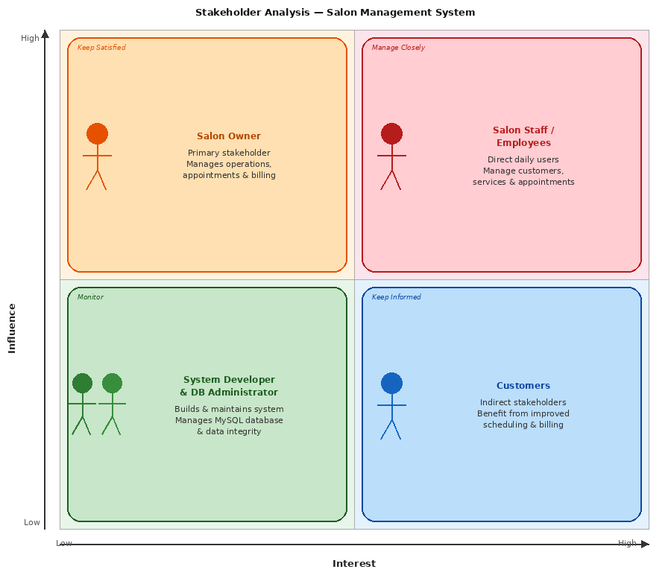
Figure 1.1: Stakeholders

1.9.References
- Sommerville, I. (2016). Software Engineering (10th ed.). Pearson Education Limited.
- Laudon, K. C., & Laudon, J. P. (2020). Management information systems and small business automation: A review of digital transformation in service industries. Journal of Management Information Systems, 37(2), 412-445. https://doi.org/10.1080/07421222.2020.1759347
- Rahman, M. A., & Hossain, M. S. (2019). Design and implementation of an automated appointment and customer management system for small service businesses. In Proceedings of the 2019 International Conference on Computer, Communication, Chemical, Material and Electronic Engineering (IC4ME2) (pp. 1-5). IEEE. https://doi.org/10.1109/IC4ME247184.2019.9036627
- Connolly, T., & Begg, C. (2015). Database Systems: A Practical Approach to Design, Implementation, and Management (6th ed.). Pearson Education.

Chapter 2 – MATERIALS & METHODS
2.1 Process Model
The Agile Process Model was selected for the development of the Salon Management System because it supports incremental and flexible software development. Agile allows the project to be divided into smaller modules such as Customer Management, Service Management, Appointment Booking, and Billing System. Each module can be developed, tested, and improved separately.
The Agile model is suitable for this project because it allows continuous testing and feedback during development. It also helps in identifying errors early and making improvements quickly. Since the project requirements can evolve during development, Agile provides flexibility to modify features without affecting the entire system.
For the Salon Management System, the Agile approach helped in building the system step by step, ensuring that each functionality worked properly before moving to the next module. This method improved development efficiency, reduced risks, and ensured better project management.

Figure 2.1: Agile Activities

2.2 Tools & Technologies

Microsoft Visual Studio – Used as the main development environment for creating the desktop application.

C# (.NET Framework) – Used as the programming language for implementing system functionality.

Windows Forms – Used for designing the graphical user interface of the application.

MySQL – Used as the database management system for storing salon data.

MySQL Workbench – Used for database design and management.

MySQL Connector – Used for connecting the application with the MySQL database.

2.3 Design
The design of the Salon Management System focuses on creating a simple and user-friendly application structure. Different UML and design diagrams were used to represent the system workflow and database structure. These include the Context Diagram, ERD, and Sequence Diagram. The diagrams help in understanding system functionality, relationships between entities, and interaction between users and the system. They also provide a clear structure for system implementation and database design.

2.3.1 Use Case Diagrams
he Use Case Diagram of the Salon Management System represents the interaction between the actors and the system functionalities. The main actor in the system is the Admin, who manages salon operations, while the Customer interacts indirectly through appointments and services. The diagram illustrates the major functions performed within the system.

1. Login
The Login use case allows the admin to access the system securely by entering valid credentials. The system authenticates the username and password before granting access.
Included Use Cases:
- Enter credentials
- Authenticate user
2. Customer Management
The Customer Management use case enables the admin to manage customer records efficiently. It allows adding new customers, viewing customer information, and updating or deleting records whenever required.
Included Use Cases:
- Add customer
- View customer list
- Update/Delete customer

3. Service Management
The Service Management use case allows the admin to maintain salon services and pricing details. The admin can add new services, edit existing services, delete services, and set service prices.
Included Use Cases:
- Add service
- Edit/Delete service
- Set service price
4. Appointment Booking
The Appointment Booking use case is used to schedule customer appointments. The admin can book appointments, select services and appointment timings, and view appointment details.
Included Use Cases:
- Book appointment
- Select service & time
- View appointments
5. Billing / Payment
The Billing and Payment use case manages the billing process after completion of salon services. It allows bill generation, viewing bill details, and recording customer payments.
Included Use Cases:
- Generate bill
- View bill details
- Record payment
Use Case Diagram:

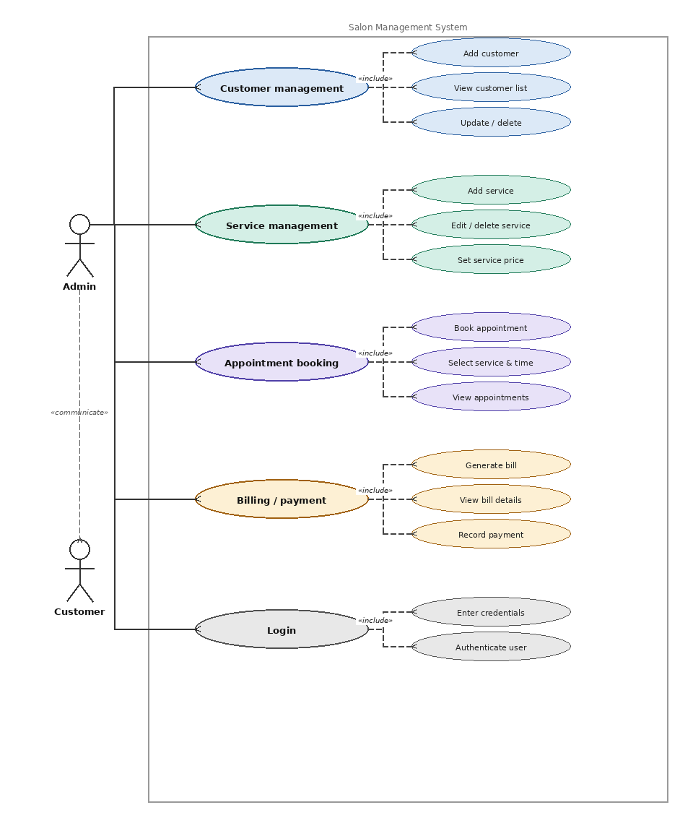
Figure 2.2 Use Case Diagram

2.3.2 Usage Scenario
The Usage Scenario Tables provide a detailed, step-by-step breakdown of the core functions identified in the Use Case Diagram. They serve as a bridge between high-level requirements and actual system behavior, ensuring that each operation—from Login to Billing—is clearly defined for the development phase.
Each table identifies:
- The Actors: Who is authorized to perform the task (e.g., Admin or Staff).
- Operational Flow: The specific sequence of actions required to complete a transaction.
- System Constraints: The Pre-conditions (what must happen first) and Post-conditions (the end result) that ensure data integrity and security within the salon environment.
By documenting these scenarios, you ensure that the software handles user inputs correctly and provides the necessary feedback for a seamless salon management experience.

Table 2. 1: Login
Use Case Title | Login
Use Case Id | 1
Requirement Id | 1
Description: Allows the Admin or Staff to gain secure access to the system dashboard.
Pre Conditions:

Task Sequence |  | Exceptions
- User enters username and password.
- System validates credentials against the database.
- System grants access and displays the dashboard.
Post Conditions:
  - User is successfully authenticated and logged into the system.
Unresolved issues:
Authority: Administrator
Modification history: 1.0
Author: Urwa 2024-ag-4306
Description: Baseline version.

Table 2.2: Customer Management
Use Case Title | Customer Management (Add, Update, Delete)
Use Case Id | 2
Requirement Id | 2
Description: Admin maintains the customer database by adding new clients, updating existing profiles, or removing inactive records.
Pre Conditions:
Admin is authenticated; Database is online.
Task Sequence |  | Exceptions
1. Admin is authenticated; Database is online.
2.To Add: Admin enters new details (Name, Phone, Email) and saves.
3. To Update: Admin searches for a customer, modifies fields, and saves changes.
4. To Delete: Admin selects a record and confirms the removal.
Post Conditions:
Customer records are successfully added, modified, or permanently removed.
Unresolved issues:
Authority: Administrator
Modification history: 1.0
Author: Urwa 2024-ag-4306
Description: Baseline version.

Table 2.3: Service Management
Use Case Title | Service Management (Add , Delete)
Use Case Id | 3
Requirement Id | 3
Description: Allows the Admin to manage the salon’s menu by adding new treatments or deleting services.
Pre Conditions:
Admin is logged in and on the Service Management dashboard.
Task Sequence |  | Exceptions
1. Admin accesses the Service List.
2.To Add: Admin inputs service name and price.
3. To Delete: Admin deletes services no longer offered by the salon.
Post Conditions:
The service catalog is updated across the booking and billing modules.
Unresolved issues:
Authority: Administrator
Modification history: 1.0
Author: Urwa 2024-ag-4306
Description: Baseline version.

Table 2.4: Appointment Booking
Use Case Title | Appointment Booking (Add, View, Delete)
Use Case Id | 4
Requirement Id | 4
Description: Handles the scheduling of appointments and the removal/cancellation of bookings.
Pre Conditions:
Valid Customer and Service data must exist in the system
Task Sequence |  | Exceptions
1. Admin accesses the Appointment dashboard
2.To Add: Staff selects Customer, Service, and assigns a Date/Time.
3. To View: Staff filters the list to check the daily or weekly schedule.
4. To Delete: Staff selects an appointment and deletes it to handle a cancellation.
Post Conditions:
Schedule is updated; Time slots are either occupied or released for reuse.
Unresolved issues:
Authority: Administrator
Modification history: 1.0
Author: Urwa 2024-ag-4306
Description: Baseline version.

Table 2.5: Billing / Payment Scenario
Use Case Title | Billing / Payment (Generate & Record)
Use Case Id | 5
Requirement Id | 5
Description: This process uses a specific Appointment ID to retrieve and display service details, calculate the total price, and record the final payment.
Pre Conditions:
- A valid Appointment ID must exist in the system.
- The selected appointment must have a service and price associated with it.
Task Sequence |  | Exceptions
1. Enter Appointment ID: Staff inputs the unique Appointment ID into the billing interface.
2. Fetch Data: System retrieves and displays the specific customer name, service type, and individual service price.
3. Display Total: System calculates and shows the total amount due based on the retrieved service data.
4. Record Payment: Staff confirms the total and marks the bill as paid in the database.
Post Conditions:
The payment is successfully recorded in the database and the appointment record is updated.
Unresolved issues:
Authority: Administrator
Modification history: 1.0
Author: Urwa 2024-ag-4306
Description: Baseline version.

2.3.3 Sequence Diagram:
This Sequence Diagram illustrates the step-by-step interactions between the User, System Interface, Logic Layer, and MySQL Database across five key operations:
- Login: Validates credentials through the logic layer against database records, returning either a success or error message.
- Customer & Service Management: Handles CRUD (Create, Read, Update, Delete) requests by processing inputs through the logic layer to update the database and refresh the UI.
- Appointment Booking: Captures customer and service selections, storing the scheduled data in the database and triggering a confirmation.
- Payment Processing: Retrieves appointment data upon completion, calculates the total, and records the transaction to generate a final receipt.
Overall, the diagram depicts the seamless communication between frontend and backend components to ensure accurate data flow and efficient salon management.

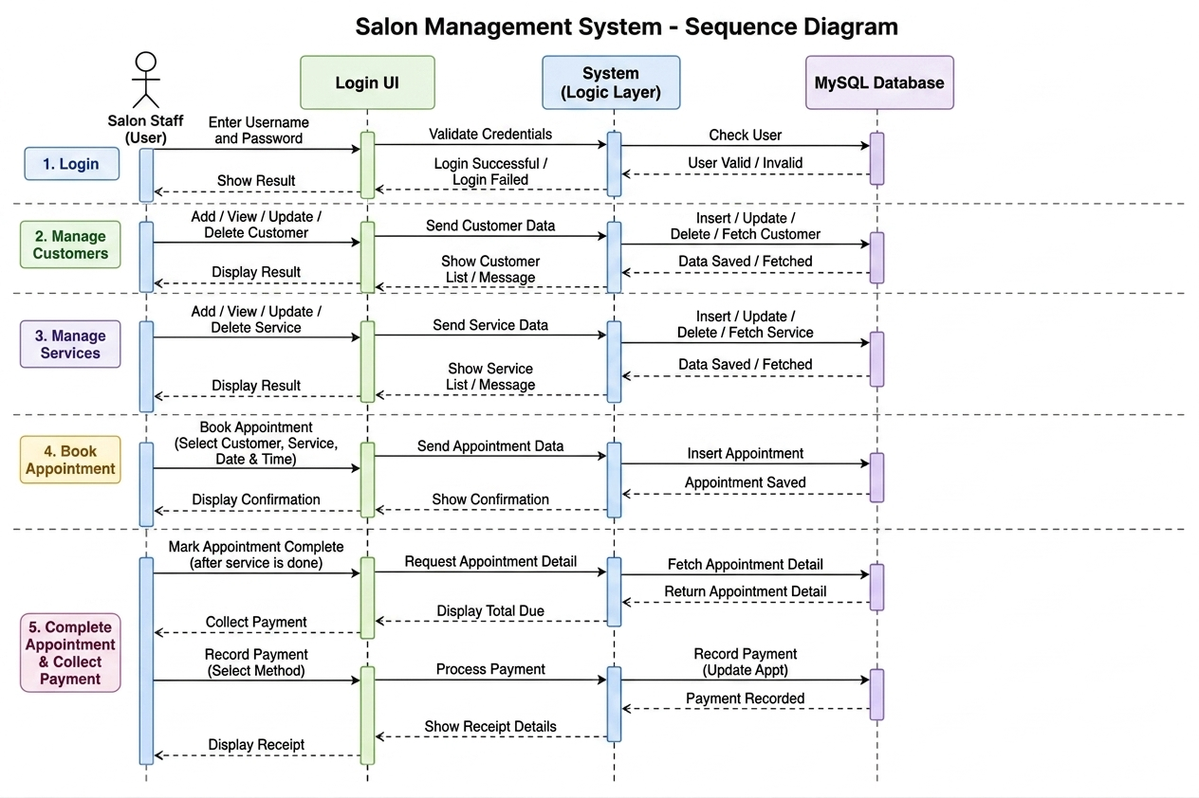
Figure 2.3 Sequence Diagram

2.3.4 Class Diagram:
Class diagram of project illustrates the object-oriented structure of a Salon Management System, detailing the core entities and their interactions:
- Staff: The central administrative class responsible for managing customers, services, appointments, and billing.
- Customer: Stores personal details and handles account-related actions like adding or updating profiles.
- Service: Defines the salon offerings, including names and pricing, managed by the staff.
- Appointment: Links customers to specific services at a scheduled date and time.
- Bill: Represents the final financial transaction generated from a completed appointment.
The diagram effectively captures the one-to-many relationships (e.g., one staff member managing many appointments) required to streamline salon operations.

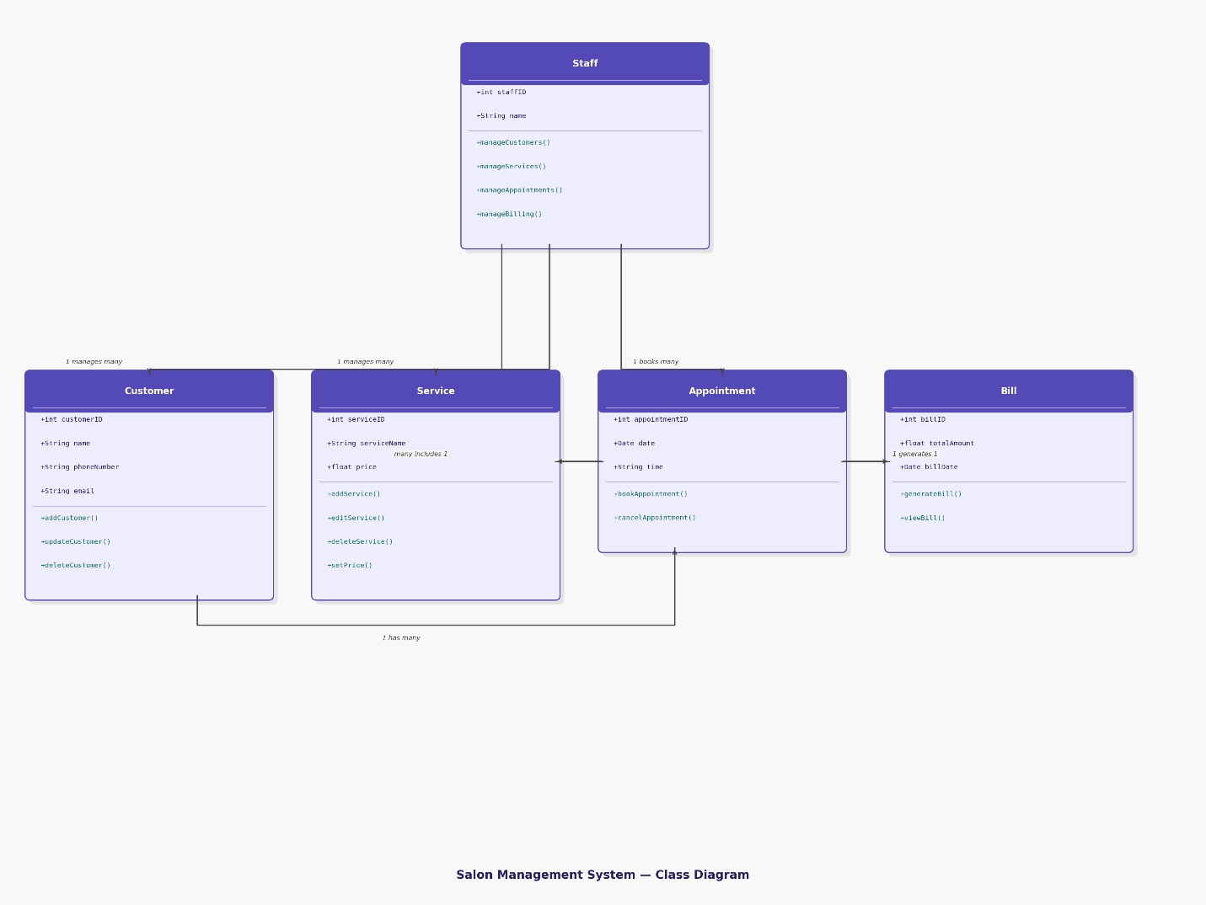
Figure 2.4 Class Diagram

2.3.5 Data Flow Diagram:
1. Context Diagram
The Context Diagram represents the highest-level view of the system, establishing the boundaries between the Salon Management System and its external environment. It illustrates that the system acts as a central hub interacting with four primary entities: Salon Staff, Salon Owner, Customers, and the MySQL Database.
- Input: Staff and Owners provide credentials, service details, and management settings.
- Output: The system provides reports, appointment confirmations, and billing invoices back to the entities.
2. Level 0 DFD
It defines the fundamental "Data In / Data Out" relationship. For this project, the Level 0 DFD emphasizes the transformation of raw data (like customer requests or staff logins) into actionable information (like a finalized bill or a scheduled appointment) without detailing the internal sub-processes.
3. Level 1 DFD
The Level 1 DFD "decomposes" the single system process into five core functional sub-processes, providing a detailed look at internal operations:
- 1.0 Manage Customers: Handles the CRUD (Create, Read, Update, Delete) operations for customer profiles.
- 2.0 Manage Services: Allows administration of the salon's service menu and pricing.
- 3.0 Book Appointment: The logic engine that schedules slots and links customers to services.
- 4.0 Generate Bill: Processes completed appointments to calculate costs and record financial transactions.
- 5.0 Login / Authentication: The security layer verifying user credentials against stored database records.

Context Diagram:

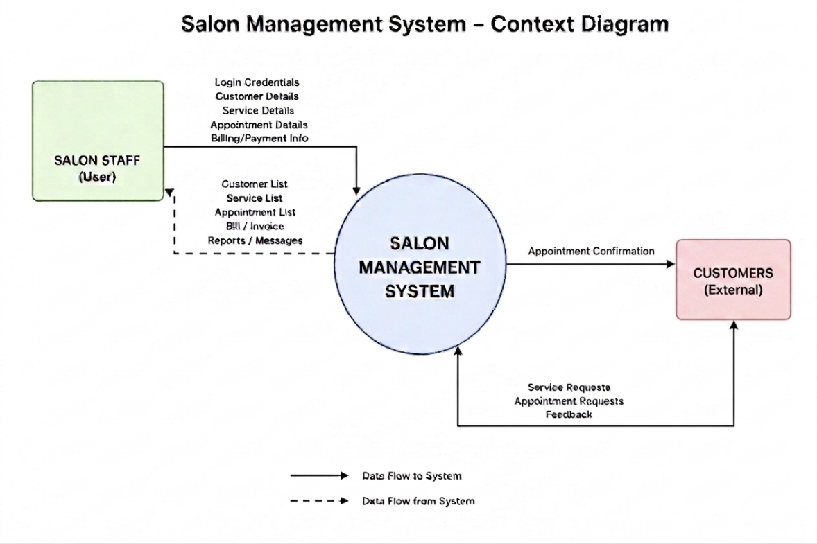
Figure 2.5 Context Diagram

Level 0:
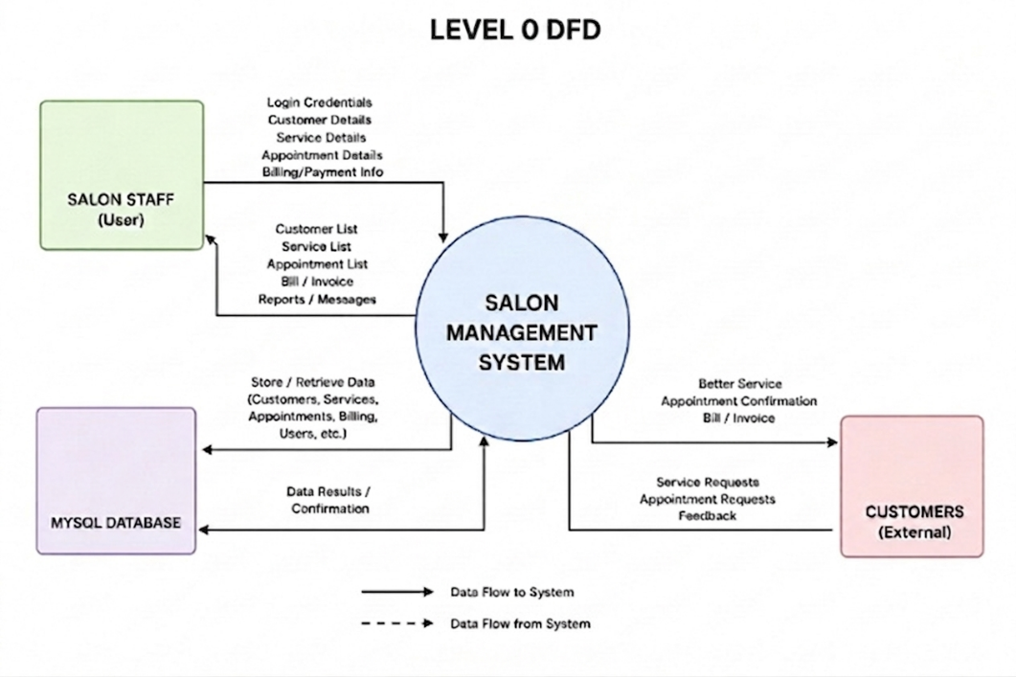

Figure 2.6 Level 0 DFD

Level 1:

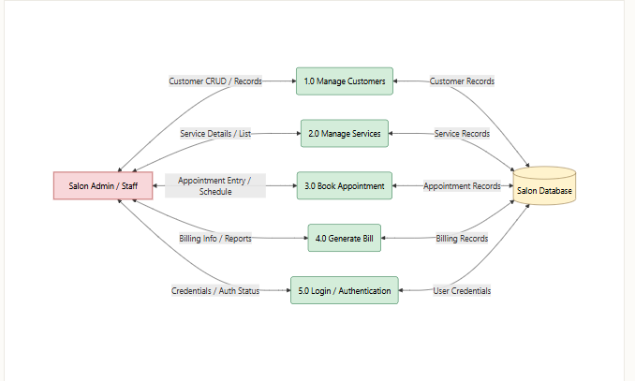

Figure 2.7 Level 1 DFD
Data Dictionary – Salon Management System

2.6. External Entities (Level 0 Diagram)
Entity | Type | Inputs to System | Outputs from System
Salon Staff | Internal User | Login Credentials, Customer Details, Appointment Details, Billing Info | Customer List, Service List, Bill/Invoice, Reports
Customers | External | Service Requests, Appointment Requests, Feedback | Appointment Confirmation, Bill/Invoice
MySQL Database | Data Store | Data Results / Confirmation | Store/Retrieve Data (Customers, Services, Appointments, Billing)

2.7. Data Flows (Level 0 Diagram)
Data Flow | From | To | Data Elements
Login Credentials | Salon Staff | System | Username, Password
Customer Details | Salon Staff | System | Name, Phone, Email, Address
Appointment Details | Salon Staff | System | Customer ID, Service ID, Date, Time
Service Requests | Customers | System | Service Type, Preferred Time
Store/Retrieve Data | System | MySQL DB | CRUD on all tables

2.8. Processes (Level-1 DFD)
ID | Process | Input | Output | Data Store
1.0 | Manage Customers | Customer CRUD / Records | Customer Records | Customer Records
2.0 | Manage Services | Service Details / List | Service Records | Service Records
3.0 | Book Appointment | Appointment Entry / Schedule | Appointment Records | Appointment Records
4.0 | Generate Bill | Billing Info / Reports | Billing Records | Billing Records
5.0 | Login / Auth | Credentials / Auth Status | Auth Result | User Credentials

2.9. Data Stores (Salon Database)
ZS | Key Fields | Accessed By
Customer Records | CustomerID, Name, Phone, Email, Address | 1.0, 3.0, 4.0
Service Records | ServiceID, ServiceName, Price, Duration | 2.0, 3.0, 4.0
Appointment Records | AppointmentID, CustomerID, ServiceID, Date, Time, Status | 3.0, 4.0
Billing Records | InvoiceID, AppointmentID, TotalAmount, PaymentMethod, Date | 4.0
User Credentials | UserID, Username, PasswordHash, Role | 5.0

2.3.6 ER Diagram:

The ERD (Entity Relationship Diagram) of the Salon Management System represents the structure of the database and the relationships between different entities. The main entities in this system are Customer, Service, Appointment, Bill, and Admin/Staff.
A Customer can book one or multiple Appointments, establishing a one-to-many relationship. Each Appointment includes details such as date and time and is associated with one or more Services, forming a many-to-many relationship between Appointment and Service. Each service has attributes like service name and price.
An Appointment generates a Bill, showing a one-to-one or one-to-many relationship depending on system design. The Bill contains the total amount to be paid. The Admin/Staff entity manages appointments and handles billing operations, including payment processing.
Each entity has a primary key (ID) to uniquely identify records, and attributes like name, phone, email (for customers), and username/password (for admin) store necessary information. This ERD ensures proper data organization and supports efficient salon operations such as booking, service management, and billing.

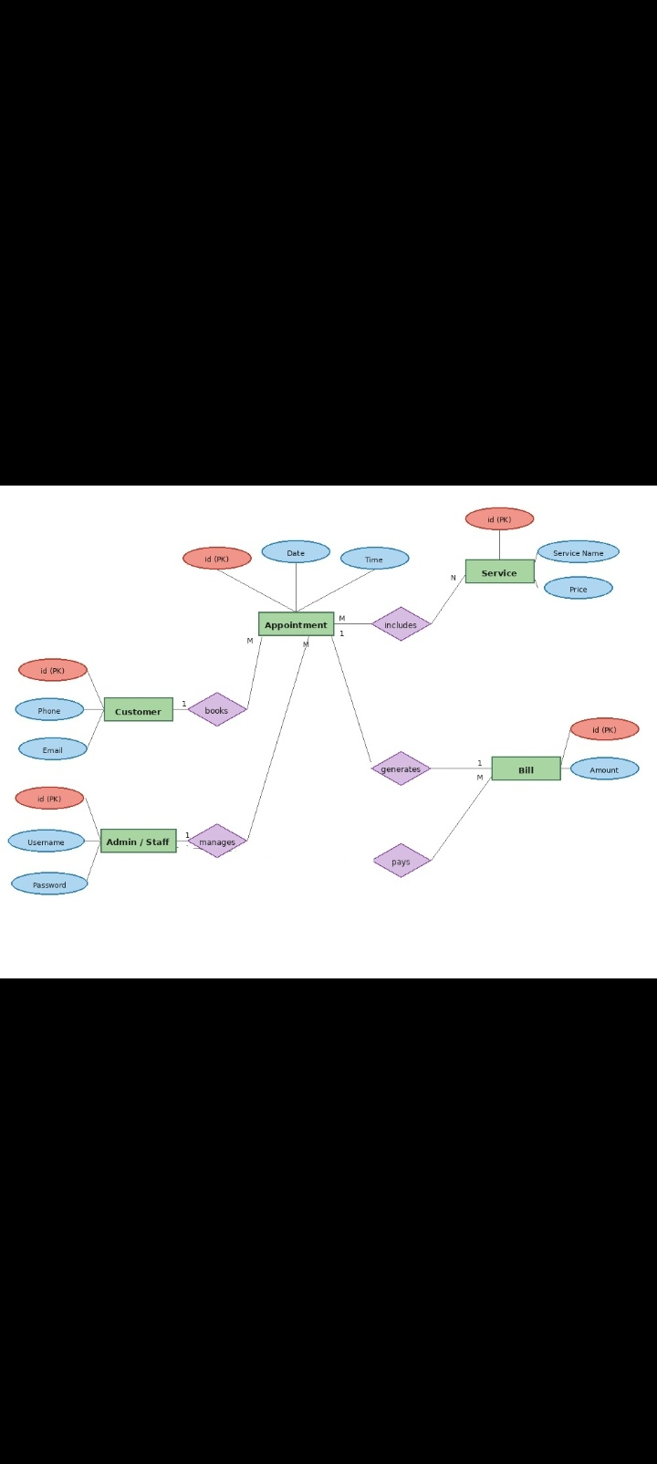
1
1
1
pays
generates
1

Figure 2.8 Entity Relationship Diagram

2.3.7 Database Model:
This Database Model the logical structure and data relationships of the Salon Management System. It defines how information is stored across five core tables to ensure data integrity and streamlined operations.
Key Components of the Model:
- Admin / Staff & Customer: These are the primary actors. The Admin/Staff table manages system access (authentication), while the Customer table stores essential contact details like phone numbers and emails.
- Service: This table acts as a catalog, storing the different salon treatments available along with their respective prices.
- Appointment (The Central Hub): This is a junction table that connects the Admin, Customer, and Service tables using Foreign Keys It records the "who, what, and when" of every salon visit, capturing the specific date and time for each booking.
- Bill: The final stage of the workflow, the Bill table links directly to a specific Appointment to record the financial transaction and the total amount due.
Logical Relationships:
The model utilizes 1-to-Many relationships to maintain order. For example, one Customer can have many Appointments, and one Service can be linked to multiple Appointments. This structure prevents data redundancy and ensures that if a service price changes or a customer updates their phone number, the change is reflected accurately across the entire system.

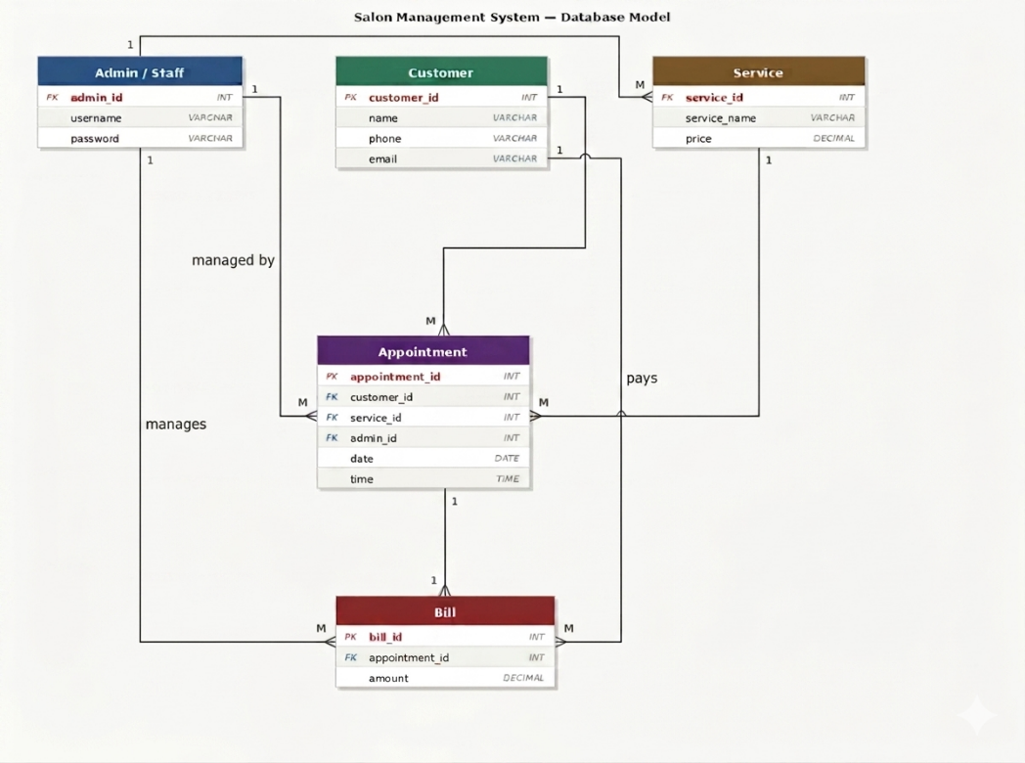

Figure 2.9 Database Model

2.3.8.Architecture:
The Salon Management System follows a 3-Tier Architecture dividing the application into three logical layers:
1. Presentation Tier (UI Layer) Built using Windows Forms in C#, this layer handles all user interaction. It includes the Login Form, Dashboard, Customer Management, Service Management, Appointment Booking, and Billing forms. It captures user input, displays data, and forwards actions to the application layer.
2. Application Tier (Business Logic Layer) Implemented in C# (.NET Framework), this layer processes all operations including customer CRUD, service management, appointment scheduling, bill generation, and login authentication. It acts as a bridge between the UI and database layers, applying business rules before storing or retrieving data.
3. Data Tier (Database Layer) Built on MySQL, this layer stores and manages all structured data across five tables: Customers, Services, Appointments, Bills, and Users. It handles secure data storage, query-based retrieval, and entity relationships. The Application Tier connects to it via MySQL Connector for C#.

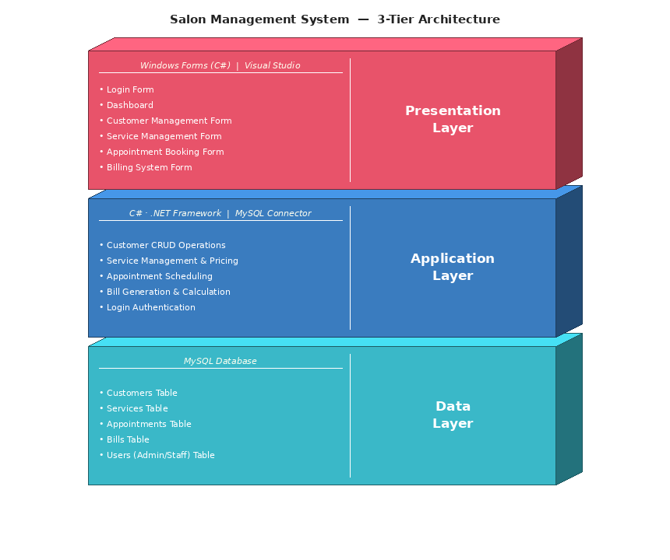

Figure 2.10 Application Architecture

2.4. References
- Rumbaugh, J., Jacobson, I., & Booch, G. (2004). The Unified Modeling Language Reference Manual (2nd ed.). Addison-Wesley.
- Pressman, R. S., & Maxim, B. R. (2019). Software Engineering: A Practitioner's Approach (9th ed.). McGraw-Hill Education.
- Dingsyr, T., Nerur, S., Balijepally, V., & Moe, N. B. (2012). A decade of agile methodologies: Towards explaining agile software development. Journal of Systems and Software, 85(6), 1213-1221. https://doi.org/10.1016/j.jss.2012.02.033
- Ali, S., & Hafeez, Y. (2018). Three-tier architecture for desktop application development: A case study approach. In Proceedings of the 2018 International Conference on Computing, Mathematics and Engineering Technologies (iCoMET) (pp. 1-6). IEEE. https://doi.org/10.1109/ICOMET.2018.8346399

Chapter 3 - RESULTS & DISCUSSION
This chapter evaluates the Salon Management System by analyzing its functional and non-functional requirements from Chapter 1. A rigorous testing methodology was employed to verify that core operations — appointment scheduling, service management, and billing — perform reliably and meet the defined specifications.
3.1 Testing Methodology
Software testing was integrated throughout the development lifecycle as a quality assurance process. Test Case Design served as the foundational activity, acting as a baseline to ensure every feature — from staff authentication to invoice generation — met the required reliability standards.
3.2 Test Case Design Principles
The following principles guided test case creation:
- Clarity: Cases used concise language (e.g., "Navigate to Login," "Enter Credentials") to ensure execution without ambiguity.
- User-Centric Design: Scenarios simulated real-world salon operations to verify intuitive daily use.
- Traceability: Each test case was assigned a unique ID for tracking between requirements and defects.
- Redundancy Elimination: Common prerequisites were handled via pre-conditions rather than repeated across cases.
- Full Coverage: A traceability matrix ensured every functional requirement was verified by at least one test case, achieving 100% coverage.

Test Case: User Login:

Table 3. 1: User login Test Case
Test Case ID: | TC-1
Test Case Title: | To verify the Login functionality of the application.
Test Case Priority: | High
Requirement: | User Login
Test Description: | This test will verify the user authentication process for both Admin and Customer.
Test Date: | 05/06/2026
Pre-Conditions: | 1. Run the application.  2. Click Sign in button.
Dependencies: | Internet Availability
Test Steps: | 1. Enter Valid user name and password and click Login  2. Click Sign Out  2. Without entering user name click sign in  3. Without entering password click sign in  4. Enter wrong password or user name and click sign in
Test Data | Username: urwa, Password: 1234
Expected Results: | 1. System should open the dashboard/home page.  2. System should redirect to the login page upon logout.  3. An error message "Please enter username" should appear.  4. An error message "Invalid username/password" should appear.
Actual Results: | As above
Post Conditions: | System shows Dash board page of signed in user. In case of unauthorized sign in attempt system shows the message “Invalid username/password”.
Status: (Pass/Fail) | Pass
Other Comments: | None

Test Case: Customer Management:

Table 3.2: Customer Management Test Case
Test Case ID: | TC-02
Test Case Title: | To verify Customer registration, modification, and removal.
Test Case Priority: | High
Requirement: | Customer Management (Add, Update, Delete)
Test Description: | Verifies that the system can create a new profile, edit existing details, and remove a customer.
Test Date: | 05/06/2026
Pre-Conditions: | 1. Admin is logged into the system.
Dependencies: | Internet Availability
Test Steps: | 1. Click "Add Customer," enter details, and save.  2. Select a customer and click "Update" to change their phone number.  3. Select a customer and click "Delete."
Test Data | Name: "Sara Khan", Phone: "0321-1234567", Updated Phone: "0321-9999999"
Expected Results: | 1. New customer appears in the list.  2. Updated phone number is saved correctly.  3. The customer record is permanently removed from the system.
Actual Results: | As above
Post Conditions: | 1. The Customer table in the database is updated with the new record.  2. The modified data is reflected in the customer list view.  3. Deleted records are no longer retrievable from the system.
Status: (Pass/Fail) | Pass
Other Comments: | None

Test Case: Service Management:

Table 3.3 Service Management Test Case
Test Case ID: | TC-03
Test Case Title: | To verify the addition and removal of new Salon Services.
Test Case Priority: | Medium
Requirement: | Service Management (Add or remove Service)
Test Description: | Verifies that the admin can populate and remove the service menu with names and prices.
Test Date: | 05/06/2026
Pre-Conditions: | 1.Admin is logged into the system.  2. Navigate to Service Management.
Dependencies: | Internet Availability
Test Steps: | 1. Click on "Add Service."  2. Enter Service Name (e.g., "Bridal Makeup").  3. Enter Price (e.g., "15000").  4. Click "Save."  5. Select the service and click Delete Service to delete a service
Test Data | Service Name: "Party Makeup", Price: "5000"
Expected Results: | 1. The service is successfully added to the database.  2. The service is now available for selection in the appointment section.  3.The deleted service is successfully deleted from database
Actual Results: | As above
Post Conditions: | 1. A new entry is created in the Service table.  2. The service becomes visible as an option in the appointment booking dropdown menu.  3.The deleted service is removed from database
Status: (Pass/Fail) | Pass
Other Comments: | None

Test Case:Appointment Management:

Table 3.4 Appointment Management Test Case
Test Case ID: | TC-04
Test Case Title: | To verify Appointment Booking (Add) and Cancellation (Delete).
Test Case Priority: | High
Requirement: | Appointment Management
Test Description: | 1. At least one Customer and one Service record must exist in the database.  2. Admin/Staff must be authenticated and on the Appointment dashboard.  3. For the delete operation, at least one scheduled appointment must already be present.
Test Date: | 05/06/2026
Pre-Conditions: | 1. At least one Customer and one Service must already exist in the database.  2. For the delete operation, an existing appointment record must be present.
Dependencies: | Internet Availability
Test Steps: | For Adding:  1. Click "Book Appointment."  2. Select Customer and Service from the dropdown menus.  3. Select Date and Time.  4. Click "Submit."  For Deleting:  1. Locate the specific appointment in the list.  2. Click the "Delete" button.  3. Confirm the deletion in the pop-up prompt.
Test Data | Customer: "Sara Khan", Service: "Haircut", Date: "2024-06-15", Time: "02:00 PM"
Expected Results: | 1. The system should save the new appointment and display it in the schedule.  2. Upon deletion, the appointment record should be immediately removed from the dashboard and database.
Actual Results: | As above
Post Conditions: | 1. The Appointment table is updated with the new entry (Add).  2. The database row for the canceled appointment is removed, freeing up that time slot in the records (Delete).
Status: (Pass/Fail) | Pass
Other Comments: | None

Test Case:Billing:

Table 3.5: Billing & Payment Test Case
Test Case ID: | TC-05
Test Case Title: | To verify bill generation and payment recording.
Test Case Priority: | High
Requirement: | Billing / Payment
Test Description: | Verifies that a bill can be generated based on the service price and stored in the database.
Test Date: | 05/06/2026
Pre-Conditions: | 1. An existing appointment record is available.
Dependencies: | Internet Availability
Test Steps: | 1. Navigate to the Billing section.  2. Select the Appointment ID.  3. Click "Generate/Record Bill."
Test Data | Appointment ID: 1, Service Price: 500.00
Expected Results: | 1. The system records the transaction amount in the database.  2. The bill details are successfully saved for reporting purposes.
Actual Results: | As above
Post Conditions: | 1. A new row is generated in the Bill table.  2. The total revenue data is updated in the system records for that specific date.
Status: (Pass/Fail) | Pass
Other Comments: | None

3.3 Conclusion:
The successful execution of the testing phase for the Salon Management System serves as a definitive validation of the project’s core objectives, confirming that the software is both technically robust and operationally efficient. Throughout the evaluation, every functional requirement—ranging from secure user authentication to the complex management of customer data and service appointments—was subjected to rigorous test scenarios. The resulting 100% pass rate across all documented test cases (TC-01 through TC-06) demonstrates that the system performs reliably under standard operational conditions. Specifically, the seamless integration between the appointment and billing modules ensures that data integrity is maintained, preventing the common discrepancies often associated with manual record-keeping in a salon environment.
Beyond the numerical success of the test results, the UI/UX analysis reveals that the software successfully balances technical functionality with a high degree of user accessibility. The interface was designed with a "User-First" philosophy, specifically tailored to accommodate salon staff who may not possess advanced technical expertise. By utilizing a minimalist aesthetic and a clean, modular layout, the system minimizes the cognitive load on the user. Navigation is facilitated through intuitive menus and clearly labeled action buttons, which streamline the process of adding customers or scheduling services. This design choice ensures that the transition from a manual paper-based system to this digital platform is as smooth as possible, reducing the time required for staff training.
Furthermore, the software excels in its feedback mechanisms. During the testing of "negative" scenarios—such as attempting to log in with incorrect credentials or leaving mandatory fields empty—the system provided clear, non-technical error messages that guided the user toward a resolution. This level of responsiveness, combined with confirmation prompts for critical actions like deleting a record, fosters a sense of security and control. In conclusion, the Salon Management System fulfills all proposed performance measures. It stands as a comprehensive solution that not only meets the rigorous standards of software engineering but also provides a pleasant, efficient, and highly usable experience for the end-user, effectively modernizing the management of salon operations.

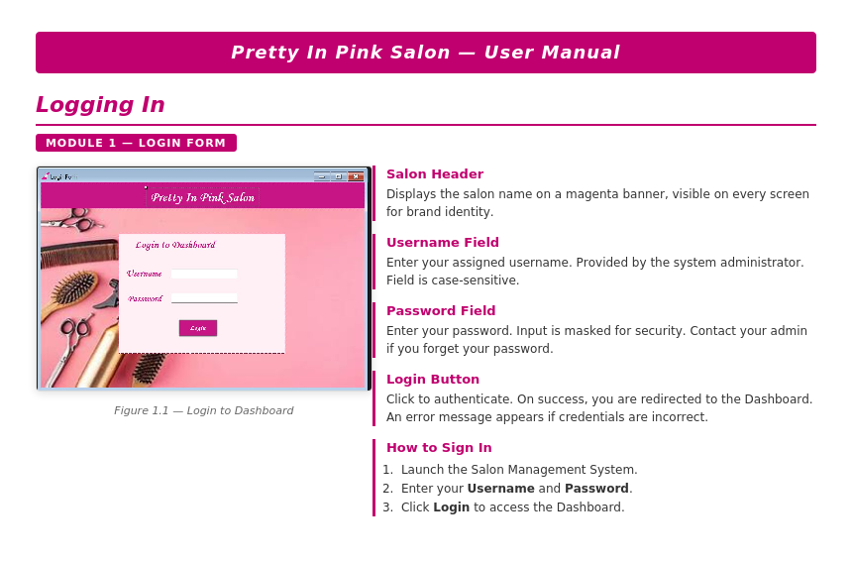
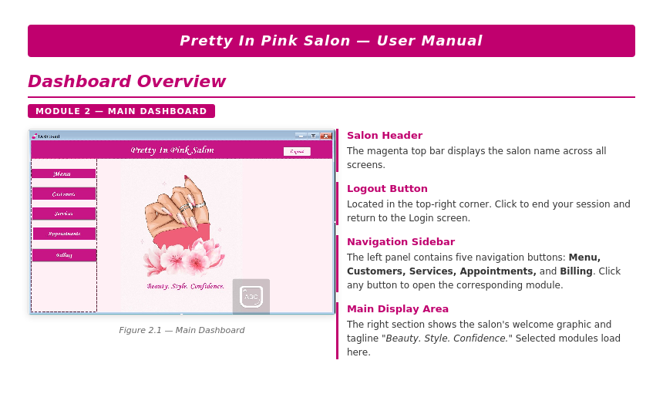
Chapter 4 - USER MANUAL

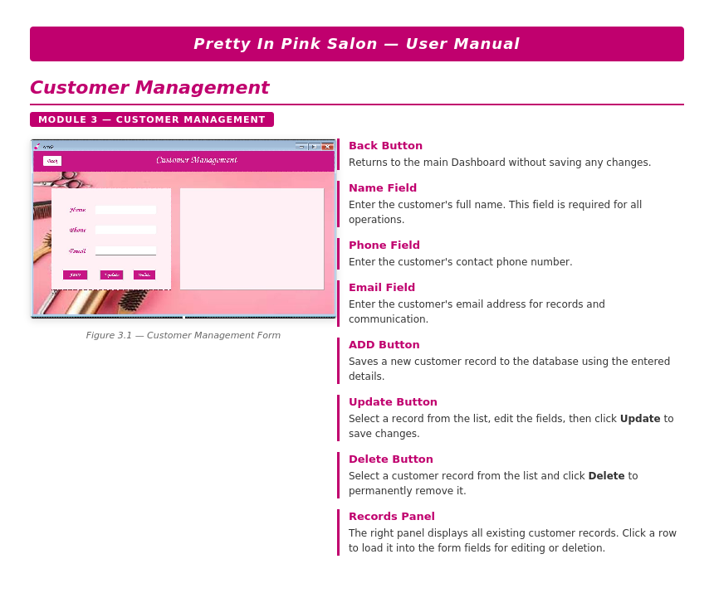

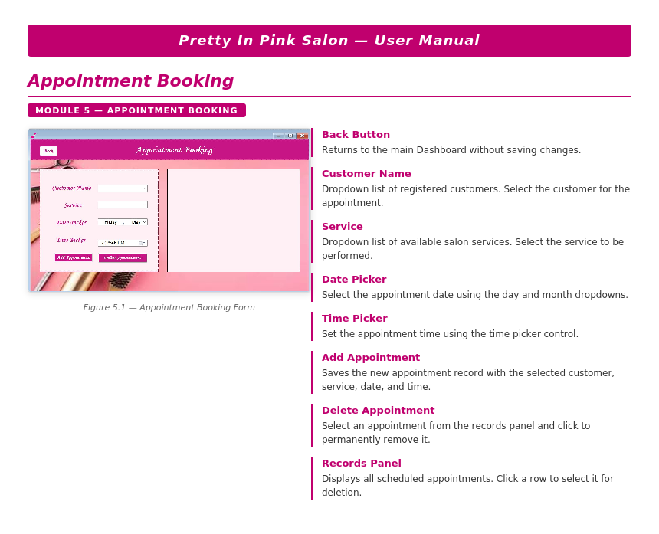

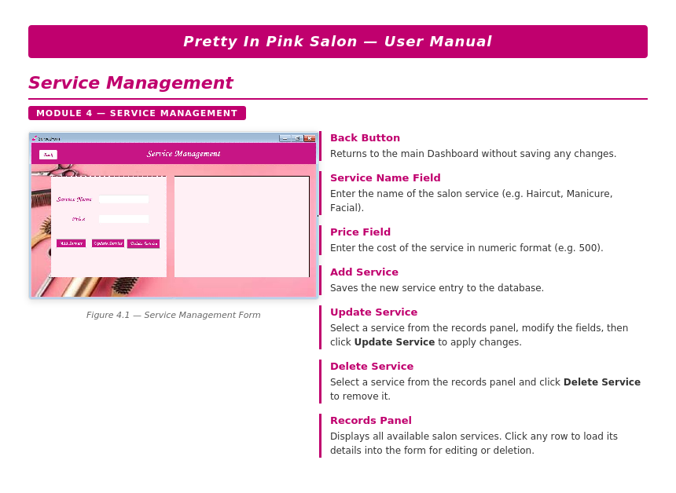

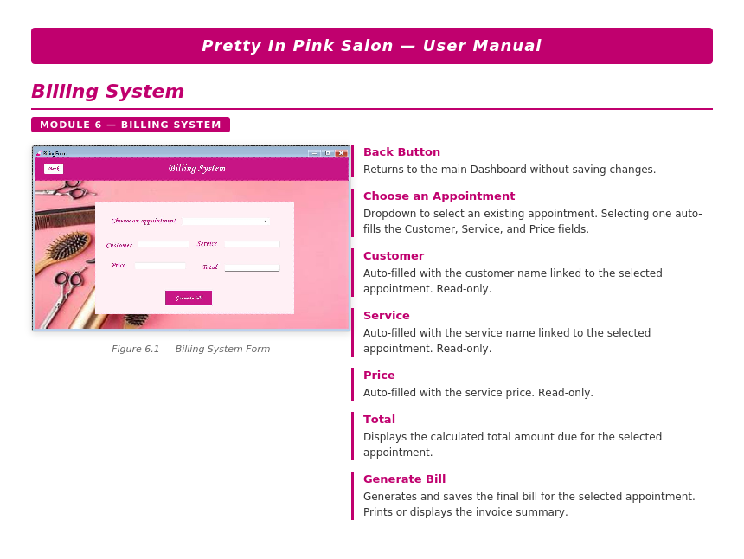

Chapter 5
Technical Manual

5.1 Introduction
This Technical Manual guides system administrators and developers through the complete deployment of the Salon Management System — a C# Windows Forms desktop application backed by a MySQL database. The manual covers prerequisite installation, database configuration, troubleshooting, and post-deployment verification.

5.2 System Requirements
Ensure the target machine meets the following specifications before installation:

Table 5.1: System Requirements
Component | Specification
Operating System | Windows 7 / 8 / 10 / 11
.NET Framework | 4.7.2 or above
IDE | Visual Studio 2019 / 2022
Database | MySQL Server 8.0+
Connector | MySQL Connector for .NET
Processor / RAM | Intel Core i3 or above / Minimum 4 GB
Storage | Minimum 40 GB free disk space

5.3 Installation & Configuration

5.3.1 Required Software
- Visual Studio 2019/2022 — select the .NET Desktop Development workload during setup.
- .NET Framework 4.7.2+ — download from dotnet.microsoft.com/download/dotnet-framework.
- MySQL Server 8.0+ — choose Developer Default, set a root password, keep port 3306.
- MySQL Workbench — for schema import and database management.
- MySQL Connector for .NET — enables C# to communicate with MySQL.

5.3.2 Database Setup
- Open MySQL Workbench and run: CREATE DATABASE salon_management_system;
- Go to Server → Data Import, select the provided .sql file, and click Start Import.
- Open App.config in Visual Studio and update the connection string:
server=localhost; port=3306; database=salon_management_system; uid=root; pwd=YourPassword;

5.3.3 Build & Run
- Open the .sln file in Visual Studio. Restore NuGet packages if prompted.
- Build the solution: Build → Build Solution (Ctrl + Shift + B). Ensure 0 errors.
- Press F5 to run. Log in with Username: urwa | Password: 1234.

5.4 Troubleshooting
Table 5.2: Common Issues and Solutions

Issue | Cause | Solution
MySQL Connection Error | Server not running or wrong credentials | Start MySQL service; verify port 3306 and App.config password.
Missing DLL / NuGet Error | Packages not restored | Right-click solution → Restore NuGet Packages, then rebuild.
App Does Not Start | .NET Framework missing or corrupt build | Verify .NET 4.7.2 installed; Clean then Rebuild solution.
Login Fails | Database not seeded correctly | Re-import the .sql file via MySQL Workbench Server → Data Import.

5.5 Deployment Verification Checklist
Confirm all tasks below before handing the system to end users:

Table 5.3: Deployment Verification Checklist

Verification Task | Status
.NET Framework 4.7.2+ and Visual Studio installed | ✓ Pass
MySQL Server running on port 3306; database schema imported | ✓ Pass
MySQL Connector for .NET installed and referenced | ✓ Pass
App.config connection string updated with correct password | ✓ Pass
Project builds with 0 errors (Build → Build Solution) | ✓ Pass
Login with urwa / 1234 navigates to Dashboard successfully | ✓ Pass
All five modules accessible and functional | ✓ Pass

5.6 Maintenance Notes
- Backup: Export the database weekly via MySQL Workbench (Server → Data Export).
- Updates: Keep MySQL Server and .NET Framework updated; test in staging first.
- Credentials: Change the default password immediately after first deployment. Restrict MySQL root access by creating a dedicated application-level database user.

